1. Install

Name: Hun Ravit

ID: e20180328

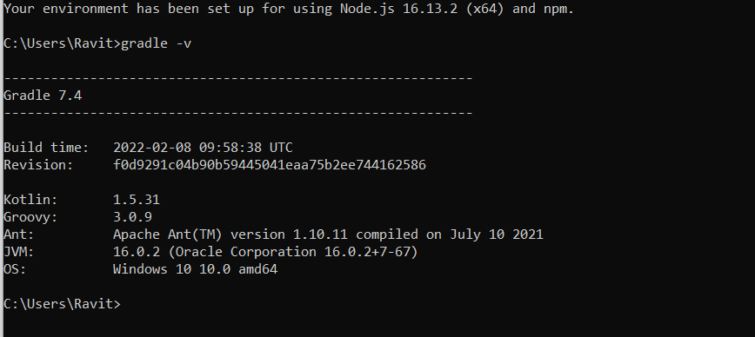

1. 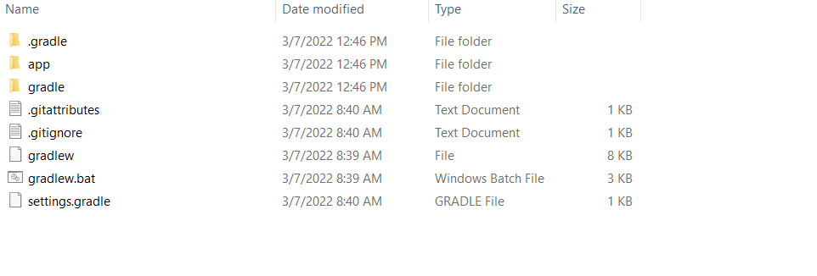Create Project
2. Connect with Mysql

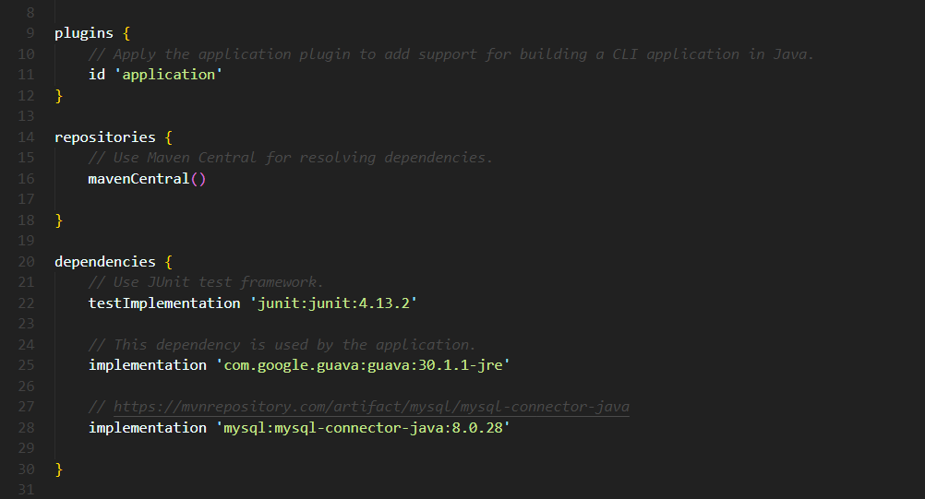

1. Create Table

**CREATE** **TABLE** products(

`id` **INT** **PRIMARY** **KEY** **AUTO_INCREMENT**,

`name` **VARCHAR**(150),

`price`**FLOAT**,

`created_date` **DATE** **DEFAULT** **CURRENT_DATE**

);

1. Connect to project

I used this command to run (**gradlew --console plain run** ).

Because If I used command **gradle run, It work but it cannot find java.util.Scanner**

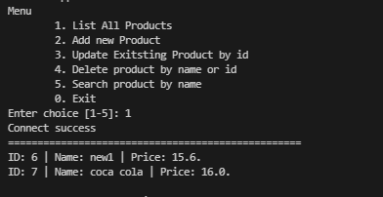

**List Product**

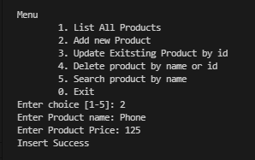

**Add new Product**

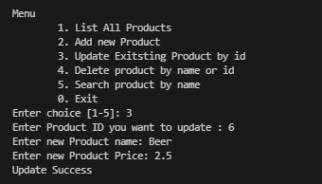

**Update product by id**

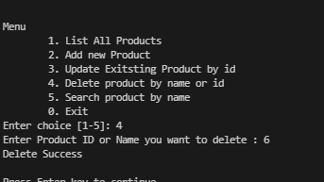**Delete Product by name or id**

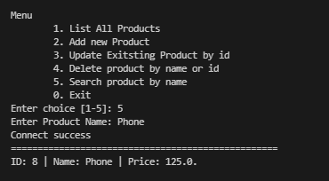

**Search Product name**